

Lab 3: Addition of Keypad to LCD I/O to Cooperative Multitasking for LED Blinking

ME 305-03

November 2, 2015

Carter Price

Sarah Visitacion

**Objective**

The objective of this lab was to add on input-output capability to what was done in Lab 2. The user is able to enter a decimal integer that represents the number of milliseconds in the period for the specified LED pair. Magnitudes that are accepted range from 1 to 65,535. Errors are shown when no digits are entered, a zero magnitude is entered and when the magnitude is too large. The current number of milliseconds is displayed on the LCD. As in Lab 2, the LED pairs blink in the following order:

G_LED ON and R_LED OFF

G_LED OFF and R_LED OFF

G_LED OFF and R_LED ON

G_LED OFF and R_LED OFF

G_LED ON and R_LED ON

G_LED OFF and R_LED OFF

**Tasks**

Task 1: Mastermind

This task tracks the various flags and branches accordingly. The states are listed below.

* State 1: Mastermind hub: Keeps track of the various flags and branches according to which flags are set
* State 2: SHOW: Counts the time to show an error
* State 3: RESETSHOW: Clears the SHOWflag and resets SHOWCOUNT
* State 4: RESETL1: Resets L1 and clears F1flag and F2flag
* State 5: RESETL2: Resets L2 and clears F1flag and F2flag
* State 6: Prompt 1: Sets the DLINE1 flag
* State 7: Prompt 2: Sets the DLINE2 flag
* State 8: F1Press: When F1 is pressed and the numbers pressed will be displayed on the screen
* State 9: F2Press: When F2 is pressed and the numbers pressed will be displayed on the screen
* State 10: clrBUFF: Moves the contents of buffer into pointer, counts what is being stored in buffer
* State 11: ENTERpress: Occurs when Enter is pressed
* State 12: NODIG: Occurs when no digits are entered, DIGITflag is set
* State 13: DIGITpress: Tests if F1 or F2 were pressed
* State 14: PROCEED: Makes sure there are no more than 5 digits being entered
* State 15: ERROR: Returns if something other than a digit is pressed
* State 16: MAXdig: Occurs when 5 digits have been entered
* State 17: BACKSPACE: Occurs when backspace has been pressed
* State 18: NOBS: If there are no digits entered, then user cannot backspace
* State 19: BCD: Converts digits from ASCII to BCD
* State 20: Indicates the number entered is above 65,535
* State 21: ZERO: Zero was entered (zero magnitude is not possible)
* State 22: DONE1: Checks if result is zero
* State 23: SET1: If result is an appropriate number and F1 is pressed, it is moved into TICKS_1
* State 24: SET2: If result is an appropriate number and F2 is pressed, it is moved into TICKS_2

Task_2: Keypad Driver

This task initializes the keypad and checks to see if a button has been pressed. There are two main states. The first one initializes the keypad and the second tests the L$KEY_FLG to see if a key is available and had been pressed.

Task_3: Display State

This task controls the LCD display module based on the flags that are set:

* State1: Display Hub - checks to see what is to be displayed based on the various flags that have been set.
* State 2: Init Display1: Displays the initial prompts top row
* State 3: Init Display 2: Displays the initial prompts bottom row
* State 4: HIGHdis- Displays the error for a magnitude too high
* State 5: NODIG- displays error for no digits entered
* State 6: Zerodis - displays error for a value of zero entered
* State 7: Toptime - this is the hub for when the user is inputting digits for LED_1
* State 8: Bottomtime-this is the hub for when the user is inputting digits on LED_2
* State 9: BACKSPACE - deletes the last digit entered by user
* State 10: Firstdig - secures the starting address for the first digit to be displayed
* State 11: Ddigit - displays the next digit entered and addst to buffer
* State 12: Cline1 - clears the previous numerical entry by user for LED_1
* State 13: Cline2 - clears the previous numerical entry by user for LED_2

Task 4: Pattern One

This task established the blinking order of the first pair of LEDs. There are seven states. State 0 ensures that all LEDs are off when Task 1 is initialized. States one through six turn on the LEDs in the pattern stated above.

Task 5: Timing of first LED pair

This task counts down the first LED pair. This task has 3 main states: state 0, state 1, and state 2. State 0 initializes Task 2 and sets the next state. State 1 initializes COUNT_1, decrements COUNT_1 and stores it. State 2 tests to see if COUNT_1 is already zero, counts down COUNT_1, decrements COUNT_1 and stores it. If it is done, the done flag is set, if it is not done then it returns.

Task 6: Pattern Two

This task established the blinking order of the second pair of LEDs. There are seven states and they are the same as Task 4, but applied to the second pair of LEDs and the associated variables.

Task 7: Timing of second LED pair

This task counts down the second LED pair. This task has 3 main states and they are the same as Task 5, but applied to the second LED pair and the associated variables.

Task 8: Delay

This task sets the delay time of 1.00 ms. There are two main states, State 0 and State 1. State 0 initializes Task 3 and State 1 sets the time delay of 1.00 ms.

**Inter-task Communication Variables**

|  |  |  |  |
| --- | --- | --- | --- |
| **Variable** | **Description** | **Set Location** | **Clear Location** |
| BACKflag | Indicates that backspace has been presses | TASK_1, BACKSPACE | TASK_1, NOBS |
| FIRSTCH | Indicates that the character being displayed is the first character | Initially set | TASK_3, DCHAR_1st |
| DLINE1 | Indicates that the initial first line is being displayed | TASK_1, PROMPT1 | TASK_3, CL1 |
| DLINE2 | Indicates that the initial second line is being displayed | TASK_1, PROMPT2 | TASK_3, CL2 |
| F1flag | Indicates F1 was pressed and line 1 is being written to | TASK_1, F1Press | TASK_1: RESETL1, RESETL2, F2Press TASK_4: START1 |
| F2flag | Indicates F2 was pressed and line 2 is being written to | TASK_1, F2Press | TASK_1: RESETL1, RESETL2, F1Press  TASK_6: START2 |
| DIGITflag | Indicates that a digit is to be displayed | TASK_1, PROCEED | TASK_1: MAXdig, Ddigit |
| COUNT | Indicates the number of digits entered | Increments in Task_3, Ddigit | TASK_1: F1Press, F2Press, SET1, SET2 |
| FIRSTdig | Indicates the first digit on the line being displayed | TASK_1, F1Press, F2Press | TASK_3, Ddigit_1st |
| TEMP | Holds the ascii value entered on the Keypad. | TASK_3 | TASK_1: RESETSHOW, F1press, F2press, ENTERpress  TASK_3: Ddigit, BS, |
| DONE_1 | communicates when to switch to next task in TASK_4 | TASK_5: setdone_1 | TASK_5: states 0 and 1 |
| DONE_2 | communicates when to switch to next task in TASK_4 | TASK_7: setdone_2 | TASK_7: states 0 and 1 |
| ON_1 | indicates if LED pair 1 should be on | TASK_1: SET1 | _main; TASK_1: F1press |
| ON_2 | indicates if LED pair 2 should be on | TASK_1: SET2 | _main; TASK_1: F2press |
| TOOHIGHflag | indicates if entered value is too high | TASK_1: toobig, | TASK_3: CHIGH |
| SHOWflag | indicates if screen should pause on an error | TASK_3: CHIGH, CNODIG, CZERO | TASK_1: RESETSHOW |
| NODIGflag | inidicates no digits were entered | TASK_1: NODIG | TASK_3: CNODIG |
| ZEROflag | indicates a zero was entered | TASK_1: ZERO | TASK_3: CZERO |
| CLINE1flag | flags to clear line 1 of entry field | TASK_1: F1press | TASK_3: CLRCLINE1 |
| CLINE2flag | flags to clear line 2 of entry field | TASK_1: F2press | TASK_3:CLRCLINE2 |

**Finite State Machines**

Task_1: Mastermind

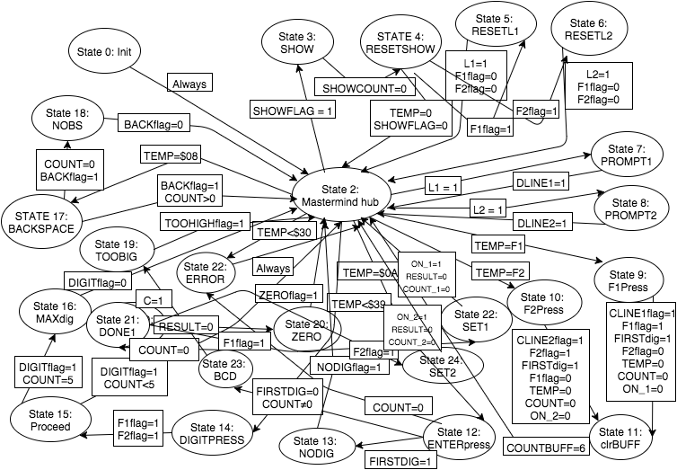

Task_2: Keypad Driver

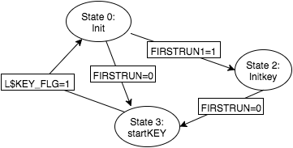

Task_3: Display task

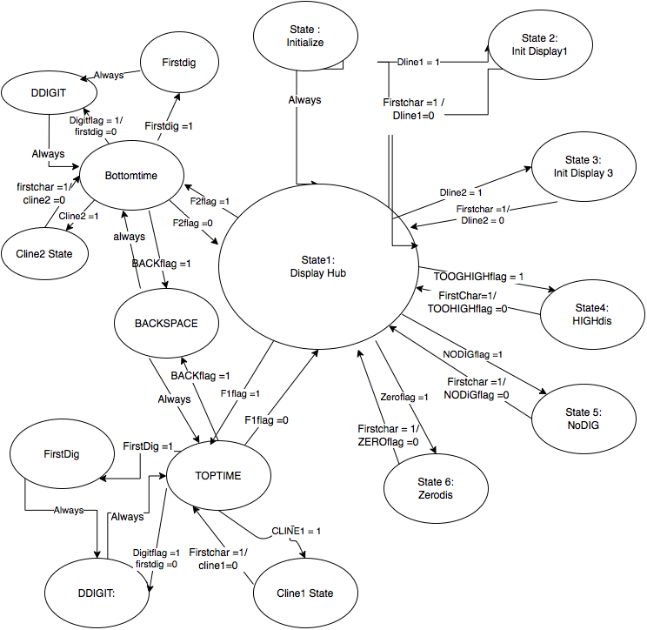

Task_4: Pattern 1 for LED pair 1

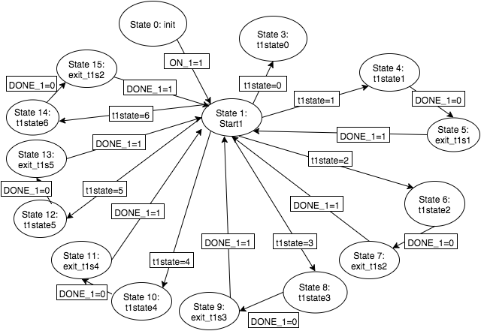

Task_5: Count Down LED pair 1

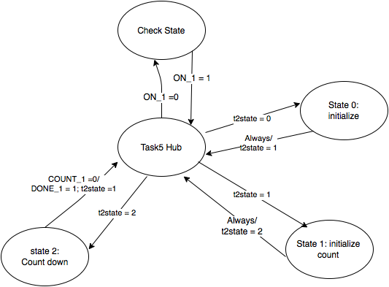

Task_6: Pattern 2 for LED pair 2

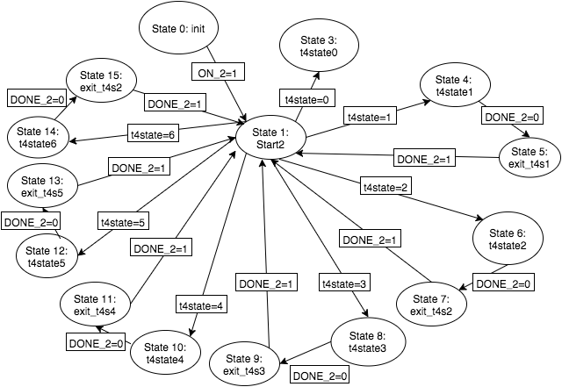

Task_7: count down LED_2 pair

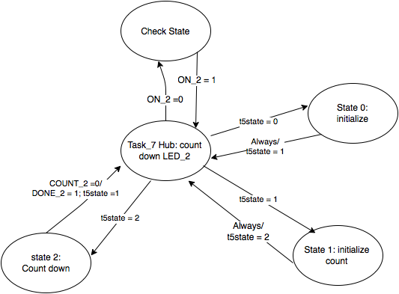

Task_8: Delay 1.00 ms

